###### 

Surface Attack Tactics (SAT) Handbook

494th vFS / 108th vFS / 388th vFS

Handbook

132nd Virtual Wing

[www.132virtualwing.org](http://www.132virtualwing.org/)

This work is licensed under a [Creative Commons Attribution-ShareAlike 3.0 Unported License](http://creativecommons.org/licenses/by-sa/3.0/).

Surface Attack Tactics (SAT) Handbook

|  |  |
| --- | --- |
| Applies to: | 494th vFS / 108th vFS / 388th vFS |
| Type: | **Handbook** |
| Version: | 0.6 |
| Published date: | 16.01.2020 |
| Document responsible: | Neck |
| summary of changes: |  |
| References: | *476th: 476TTP3.3.A10 -24APR16 (*[*LINK*](http://www.476vfightergroup.com/downloads.php?do=file&id=376&act=down&actionhash=guest)*)*  *Eddie, 476th Forums: Air-to-Surface Weapon Delivery Methods (*[*LINK*](http://www.476vfightergroup.com/showthread.php?3131-Air-to-Surface-Weapon-Delivery-Methods)*)*  *Andy Bush: Combat Mission Planning Considerations (*[*LINK*](http://www.simhq.com/_air/air_009a.html)*)*  *“Falcas”: Weapon Delivery Planner Manual by (*[*LINK*](https://burgers6.home.xs4all.nl/files/WDP1.3%20OF%20Manual.pdf)*)* |

Contents

Introduction 4

**1.** **Planning your attack.** 5

**1.1.** **Target study** 5

**1.2.** **Weapon selection** 6

**1.3.** **Type of delivery** 6

**1.4.** **Final Attack Heading and Initial Point** 7

**1.5.** **Egress heading** 7

**1.6.** **Post attack rendezvous point** 7

**1.7.** **Attack tactics** 7

**1.8.** **Contingencies** 9

**2.** **Tactics and Weapon Delivery Methods** 10

**2.1.** **Mission profiles** 10

**2.2.** **Low altitude tactics** 12

**2.2.1.** **Gun deliveries** 13

**2.2.2.** **Low Level Deliveries** 13

**2.2.2.1.** **Pop-up attacks** 14

**2.3.** **Medium/high altitude tactics.** 16

**2.3.1.** **Medium and High Level Deliveries** 16

**2.3.2.** **Toss Deliveries** 17

**3.** **Chapter 3: Useful information** 18

**3.1.** **Three Point Attack Brief** 18

**3.2.** **Fence Check** 18

**3.3.** **Attack methods** 18

**3.4.** **Mutual support Attack Geometry** 19

**3.5.** **Buddy lasing** 23

**3.6.** **Ground lasing** 23

**3.7.** **Holding patterns** 23

**3.8.** **Range pattern** 24

**3.9.** **Safe Escape Maneuvers (SEM)** 25

**4.** **Chapter 4: Z-Diagrams** 27

**4.1.** **Z-Diagrams 494th** 29

**4.2.** **Z-Diagrams 388th** 31

**4.3.** **Z-Diagrams 108th** 31

Surface attack is a challenging mission that requires complete knowledge of your aircraft systems, handling characteristics and ordnance. Given surface-to-air and air-to-air threats, the surface attack role is demanding. Surface Attack Tactics (SAT) is the tactics, techniques and procedures for conducting surface attacks effectively and safely.

# Introduction

Scope: This document outlines the Tactics Techniques and Procedures (TTP's) for surface attacks with fast jets in the 132nd Virtual Wing. Each squadron will have their own Standard Operating Procedures (SOP's) for aircraft squadron specifics in regards to surface attacks.

Content: This document is divided into 4 chapters. Chapter 1 describes planning for a successful surface attack. Chapter 2 contains tactics and weapon delivery methods. Chapter 3 contains useful information. The final chapter contains specific Z- diagrams with parameters for attack profiles for the various squadrons.

Pilot responsibility: Use common sense. TTP's describe technical and tactical procedures for most circumstances, but is no substitute for common sense and judgment. It is the pilot's responsibility to fly the aircraft safely and effectively in all circumstances, as required to accomplish the mission.

Deviations: Deviations from these TTP's are approved as long as they are communicated to all parties operating together.

Recommended changes: Improvements and recommended changes to this TTP should be stated to the Wing Command Staff.

You are a new flight lead, tasked to fly deep into enemy territory to bomb a building protected by SAM and AAAs How do you get to the target, how can you destroy it, and how do can you come back alive? This is the big questions for all strike missions.

How and what can you do?

One option is to avoid being seen. We can stay below the radar and pop up just before we drop our ordnance. This will give the enemy only a short time to track and thus a short time to aim and shoot at you. You could also stay above the threat and drop your bombs from a safe altitude. Maybe you could stay far away from the threats and toss the bomb to the target. But when do you go up? How high do you climb?

Planning is part of the answer. If you plan your attack, you will have better chances of surviving the mission. Mutual support and cooperation with your wingman and other flights is another part of the answer.

# **Planning your attack.**

What do we need? This is always a good question to start with. When you know what you need, you also know what you should be looking for. For a start we need to know what the target is. Is it a “point”, like a radar dish, or is it a long target like a bridge or building?

If it is a “point” it doesn’t matter from which direction you attack it. If it’s a long bridge you might want to think about attacking it along its axes. This way you can ripple your bombs in a “stick”. What is the elevation of the target? Is it on a mountain or at sea level? What is the threat that surrounds the target? Can you find a route around AAA and SAMs? What does the surrounding look like? There could be a mountain blocking your route during the attack or during the exit. Do we ingress at a low or a high altitude? As you can see, there is a lot to think about. This chapter will aid you through the process.

**NOTE:** Whilst all these facorts and guidelines are applicable during AR and CAS mission, the dynamic nature of these mission often deny you access to information beforehand.

## **Target study**

Prior to any mission you should gather all available information, maps, imagery and intelligence. Information can be found in various sources such as the mission brief, Air Tasking Order (ATO), target packs, DCS Mission Editor or Combat Flite.

You want to look at the overall target area. Use DCS Mission Editor or Combat Flite maps and various target photos to “see” the position of the target from a “big picture perspective.” This is very important. You might choose to approach your target at high speed and at low altitude, where your radius of vision is limited. Your attention will be split between navigation concerns and analysing, interpreting, and possibly responding to enemy threats.

Your “big picture” study has one purpose; you want to locate significant navigational references that you will use to “walk” your eyes to the target. As an explanation, let’s say the target is a truck convoy located near a bridge. As you run in to the immediate target area, you first locate the river. You follow the river until you get a tally on the bridge. You know from your target study that the truck convoy is situated in a particular direction from the bridge. Use your run in heading to the bridge as a twelve o’clock reference. Then translate the target’s location relative to the bridge into a clock position. For example, as you approach the bridge, you look to the bridge’s nine o’clock to find the target. Use this step-by-step process to get your eyes on the target in a methodical manner. Do not leave it to luck or chance to find your target. Your map and target photos make it possible to build your mental picture of this “big picture.” Using the “big picture to specific target” technique helps you find your target quickly, leaving you additional time to devote to achieving a successful one-pass attack.

Now, let’s consider what the target actually looks like. Use your maps and target photos to get a general picture of the target layout. See how long the target is. Then you can decide on ripple and spacing. Notice the colour of the target. This might help during the day. A dark building can be found nicely when it has a light background. Try to find out what the elevation of the target is. This will give you the first ideas of which attack profile to choose.

Using the convoy again as an example, determine if the convoy is strung out in a line or grouped together. Note the general compass orientation of the target. Determine if your attack heading will take you down the length of the convoy or across it. This heading is called your “attack axis.” Your weapon effectiveness is affected by your choice of attack axis. For example, when using CBU bomblets, you want to spread the bomblets along the length of the convoy rather than across it. Your target study may give you the location of that threat in the convoy.

If you are attacking a large target that requires several impacts, assess where the impact points should be placed. These becomes your DMPI (Desired Mean Point of Impact) for unguided weapons, and DPI ( Desired Point of Impact) for precision munitions. DMPI/DPI are in some cases given by higher echelon, but if they are not provided, you should identify these during your planning.

Analyze known position of AAA, SAM’s and radar stations and assess their impact on your target and plan. CombatFlite can be used to conduct detailed line of sight studies to help assess if you are visible on enemy radars or within range of AAA and SAM’s.

Make sure to take the weather into consideration. A solid overcast at 10,000ft will ensure that only coordinate dependent weapons can be used above the overcast, while you need to be below the overcast to deliver weapons on the target visually. Rain and snow can have an adverse impact on laser / IR pointer. A solid overcast can give poor NVG conditions making it hard to identify features and targets at night. What time of day will the attack take place, where will the sun or moon be in relation to your target. Can you see the target at the distance and altitude where you plan to see the target?

## **Weapon selection**

Once you have a good understanding of the big picture and the threat in the target area, you should select (if able) your requested ordnance based on the following:

* Desired effect (Probability of kill "PK")
* Desired delivery type (factored by weather, threat, frag)
* Target priority
* Weather
* CDE (Collateral Damage Estimates)
* Weapon availability

## **Type of delivery**

**Once you know what kind of weapon you will attack the target with, you will need to decide on what kind of delivery you will need to use to attack the target. You also need to decide on what kind of ingress is needed:**

**Ingress type**  
Select your type of ingress to target (LOW/MEDIUM/HIGH) based on:

* Target area threat picture
* Weather
* Weapon release envelope
* Element of surprise

**Delivery type**

Select your type of delivery for a low ingress:

* POP-UP (LALD, LAHD, LAS, HAS)
* TOSS (LAT) (also called loft)

Select your type of delivery for a medium ingress:

* TOSS (MAT)
* DIVE-BOMB (MADB)
* LEVEL

Select your type of delivery for a high ingress:

* DIVE-BOMB (HADB, HARB)
* LEVEL

## **Final Attack Heading and Initial Point**

**Final attack heading (FAH)**

FAH is the heading you want to be when employing your weapons.  
Selection criterias for FAH:

* Target layout (elongated targets ie:. bridges, runways, ships, defensive lines, roads)
* Geographical hindrance (terrain, buildings)
* Sun and moon position
* CDE (Collateral Damage Estimates)
* LTL (Laser Target Line)

**Initial Point (IP)**:

IP is where the attack(run) commences, at this point your aircraft should be fully configured for the attack and established within the ingress parameters of your attack profile. The IP in relation to your target also generates your attack-axis, the direction you approach your target from.  
Selection criterias for IP:

* Unique geographical reference suitable for altitude (high/medium(horizontal); lake, crossroads. low(vertical): hills, tower)
* Correct attack axis that complies with FAH (not necessarily direct)
* Approximately 2-3 minutes distance from weapons release
* Attack-Axis supporting visual acquisition of target

Note that in CAS and other Dynamic scenarios, the IP can be your current position during time sensitive attacks. Remember to never fly straight and level in a hostile environment.

## **Egress heading**

This is the pre-briefed heading your flight takes after employment and safe escape manoeuvre (SEM).  
Egress heading considerations:

* Threat
* Geographical cover
* Landmarks

Egress heading is often referred to as OFF, from off target. "off left", "off reference 270".

## **Post attack rendezvous point**

Post attack rendezvous point (RV) is a grid or geographical reference point where the flight rejoins post-attack if they are unable to do so visually during egress. A deconflicted post-strike RV should be pre-briefed.  
RV planning considerations:

* Threat
* Risk vs. Reward (prolonged exposure vs. flight integrity)
* Weather

## **Attack tactics**

Now we are getting down to the details. The best attack plan is one that assures target destruction and maximizes the enemy’s surprise and confusion. The attack phase starts at the IP. Plan your run in to do two things: approach the target unobserved or undetected and, if you have additional flight members, from opposite attack directions. Use terrain masking to best advantage. You can split your four ship into two elements to attack from opposing directions at the same time. If you are in a two ship, you can still do this and remain in visual support for each other.

Your choice of attack plan will hinge directly on the threat level of enemy defenses in the target area. We divide our tactics into two types either “high threat” or “low threat”. A high threat situation typically includes SAMs and radar controlled, large caliber (37mm and above) AAA, while a low threat area is generally thought of as one having only small arms, light AAA, or man-portable SAMs (MANPAD).

**Tactics For A High Threat Environment**  
If the target is well defended by SAMs and AAA, then plan a low altitude attack using terrain masking. Two attacks that work well in a high threat environment are “shooter-cover” and “decoy.” “Shooter-cover” means one pilot attacks the target while the other looks for a threat and then attacks the threat if necessary. In a “decoy” attack, one pilot (or flight, if attacking in elements) exposes himself to the threat while the other pilot attacks from a different direction. Use stand-off weapons or delivery methods whenever possible. Use “Toss/Loft” deliveries for freefall weapons. Avoid overflight of the target if at all possible. The pop-up attack is a favored maneuver for these tactics.

The pop-up attack is a often flown tactic in the low altitude, high threat environment. It works well with both shooter-cover and decoy attacks. The target is approached at minimum altitude and at weapons release airspeed or higher. At this time the target may not be in sight. At a pre-planned distance from the target, the attacking pilot begins a climb, acquires the target, and then rolls inverted and pulls down to the desired dive angle for the attack. The cover or decoy pilot flies a similar maneuver and offsets his flight path as necessary from the attacker. The cover pilot offsets only enough to establish visual contact with the target area, and begins his pop-up at the same time as the attacker. The decoy pilot takes a greater offset , and he typically turns away 30 degrees from the attacker and times his turn back towards the target to achieve approximately a 90 degree difference in attack heading. The decoy pilot begins his pop-up before the attacker because the objective is to draw the defender’s attention well away from the direction the attacker will come from.

The pop-up attack is planned in great detail. The attack profile is planned for a specific dive angle and release altitude and math formulas are used to compute the required distances from the target. The calculations are used to find the “pop” point and the “pull down” point. Once these are known, the map is used to plan an approach to the pop point.

**Tactics For A Low Threat Environment**  
In a low threat environment, use medium or high altitude tactics to stay out of the AAA/MANPAD threat. As a general rule, stay above 5,000’ above target elevation to remain clear of most small arms and light AAA, and 12,000’ to stay above MANPADs. Trail formation is a good low threat choice. Orbit the target in a “wheel” and attack individually. Plan for thirty seconds separation between each flight member’s attack for frag avoidance.

**Weapons Frag Envelope**  
Regardless of which attack profile you fly, at some point you are going to have to deliver the weapon. Some attack profiles require the attacking aircraft to overfly the target area. This results in the need for the attacker to be aware of and avoid the destructive effects of his own weapon. Each weapon has a fragmentation (frag) envelope. This envelope has three parameters: height above ground, length or width, and duration in seconds. Plan your weapons release to avoid flying through the effects of your own weapon’s explosion or through another pilot’s weapon’s frag envelope. The best way to avoid fragging yourself is to follow the minimum release altitude info. Do not continue your dive below release altitude. Avoid fragging your wingman by separating your attacks on a common target by at least thirty seconds or by simultaneously attacking targets that are at least 1/2 mile apart.

**Re-Attack Considerations**

A re-attack of the target should be avoided if possible. If a re-attack cannot be avoided, then do not repeat the initial attack plan. Exit the target area, and use a new IP if you can. You can expect the enemy to be ready for you the second time around. Since you can expect target area defenses to be at the ready, your second attack should emphasize threat suppression along with target destruction. Use shooter-cover or decoy tactics.

## **Contingencies**

**Threat reactions**  
Your study of the threat will help you anticipate any threat indications that you may encounter during the mission. In particular, be prepared to quickly identify enemy SAM threats. Know the difference between being “painted” (“DIRT”) by enemy radar versus being locked up (“MUD”) versus actually being fired at (”SINGER”). While being “painted” is never a comfortable feeling, it may not require a defensive reaction. On the other hand, a “launch” warning is a serious matter and almost always will require a defensive reaction. Decide ahead of time what you will do for a given threat indication. Your defensive reactions vary from doing nothing in response to a minor radar scan to the jettisoning of your ordnance, followed by a break turn to avoid a missile in the air. The ramifications of the magnitude of these reactions to your overall attack plan should be clear. An improper defensive reaction brought about by an erroneous reading and reaction to a perceived enemy threat can result in a blown mission just as surely as if you had been shot down.

**Ingress “Fight or Flight”**  
Let’s consider whether or not your ingress to the target is unopposed. What are the implications of an attack on your flight as you make your way to the target? Should you engage, or should you attempt to avoid contact? Your decision may hinge on factors beyond your control. You may not have the fuel to engage in defensive manoeuvring. You may not be carrying weapons suitable for a prolonged defensive engagement. The “fight or flight” decision must be made beforehand. Know your mission fuel and time limitations. Decide ahead of time what you will do in a given defensive situation.

**Loss Of Flight Member / Abort Criteria**  
Know what you will do if a flight member is shot down or has to return to base. If you are planning a four ship mission, then have a three ship back up plan. This may require different formations and attack tactics. Realize that the flight lead may be the one to get shot down. Make sure you have another flight member ready to step in as the new flight lead. At some point, you may not have enough flight members to complete the mission. Decide upon an abort plan and be ready to use it. It is foolhardy to press on if you do not have enough munitions on the remaining aircraft to destroy your target.

# **Tactics and Weapon Delivery Methods**

## **Mission profiles**

**High Altitude Tactics**

High altitude tactics are generally flown over 25,000 feet mean sea level (MSL). Aircrews use high altitude tactics to remain above the threat's low to medium altitude surface to air systems.

##### Advantages

• Reduces aircraft fuel consumption.

• Reduces aircraft navigation difficulties.

• Improves aircraft tactical formation control and employment.

• Reduces aircrew workload.

• Allows considerable airspace for aircraft maneuver for target attack and threat reactions.

• Improves communications between aircraft and control agencies.

• Increases the range of weapon deliveries because of easier recognition and acquisition of large targets (e.g., buildings or large troop and vehicle concentrations) with aircraft sensors.

• Allows flight over the threat's AAA and medium altitude SAM systems.

##### Disadvantages

• Enemy acquisition radar can detect the attack forces at longer ranges. This may allow the enemy to alert air defence assets of incoming Counterland missions.

• May require a strong Counterair warfare support packages to degrade or suppress the enemy's air defence assets.

• Enemy high altitude SAM systems have longer-range employment envelopes to counter friendly aircraft.

• Recognition and acquisition of medium to smaller targets may be very difficult.

• Unguided munitions may not be as accurate making the attack of small point targets difficult.

• Weather or environmental conditions may prevent visual acquisition of targets or target areas.

**Medium Altitude Tactics**

Medium altitude tactics are flown between 8000 to 25,000 feet MSL and have most of the same advantages and disadvantages as high altitude tactics. However, visual acquisition of some targets may be enhanced and weapons accuracy of unguided munitions may improve. In most cases, fixed-wing AR and SCAR missions will be flown at medium altitudes to prevent exposure to AAA threats and low altitude SAMs. However, in situations where the threat is negligible or the potential targets are small, a transition to low altitude may be done as required to acquire or attack smaller targets.

**Low Altitude Tactics**

Low altitude tactics are flown below 8000 feet above ground level (AGL). Aircrews use low altitude tactics to keep the attack force below enemy early warning radar coverage as long as possible. Marginal weather or attacking smaller targets may cause aircrews to use low altitude tactic attacks. Low altitude tactics may be utilized when attacking targets within the FSCL to aid in the identification of friendly surface force and prevent fratricide.

##### Advantages

• May be used to surprise the enemy by reducing the enemy's reaction time due to terrain masking and late radar detection.

• Reduces the chance of attack from enemy SAM systems by using terrain for masking.

• Reduces the enemy's SAM weapons envelope and lethal zones during high-speed low altitude ingress and egress.

• Increases the aircrews' ability to recognize and acquire smaller targets.

• Improves aircraft maneuvering performance.

• Reduces the capability and range of the enemy aircraft radar to detect friendly aircraft.

• Allows aircrews to acquire targets during degraded weather or reduced visibility.

• May be utilized below an overcast or reduced visibility.

##### Disadvantages

• May allow enemy visual or listening posts to detect incoming aircraft.

• Visual acquisition of the target may be delayed as altitude decreases.

• Aircraft fuel consumption may be higher.

• Navigation and terrain avoidance are more demanding and require a higher level of aircrew skill.

• Exposure to small arms, AAA systems, and IR-guided weapons increases.

• Less time available for aircraft to react to enemy surface to air systems.

• Communication and control are more difficult.

During the execution of Counterland operations, mission commanders or flight leads may determine it is more beneficial to use a combination of altitude profiles. For example, the target may be a great distance from aircraft operating bases, however, the target is very small or the cloud cover is low. In this case the Counterland flight may use a high altitude ingress, low altitude target attack, and a high altitude egress. The combination of altitude profiles should be designed to optimize the aircrews' ability to attack targets, maximize the advantages of some profiles, and minimize the disadvantages associated with others.

#### Example mission profiles

**High-High-High Low-Low-High**

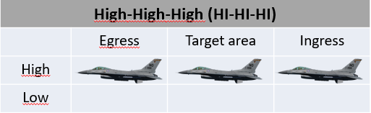 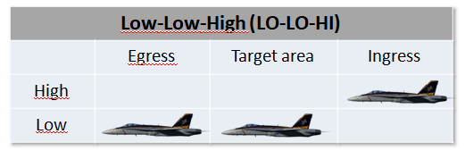

##### **High-Low-High Low-Low-Low**

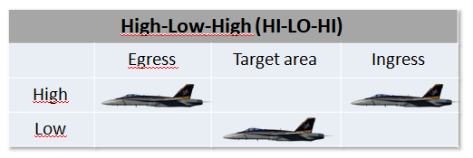 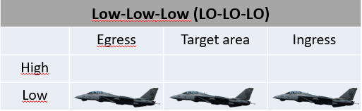

##### **High-Low-Low**

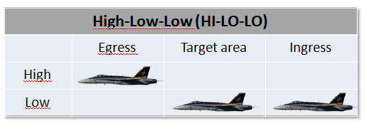

## **Low altitude tactics**

Are flown below 8,000ft AGL. Low altitude bombing can be described as bombing with height of release between 500 and 8,000ft AGL. These tactics are employed when threat system capabilities and/or weather conditions preclude aircraft operating at higher altitudes.

**Types of delivery**

**Level:** Deliver ordnance with a wings level pass over the target

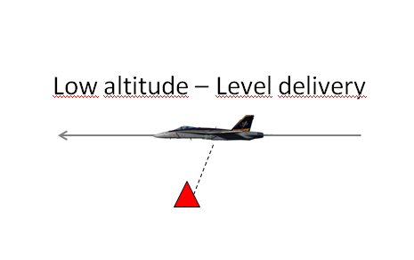

**Loft:** To execute a loft delivery the flight proceeds inbound to the target from the IP. At a calculated point the aircrew starts a loft maneuver pull up. Once released the weapon continues an upward trajectory while the aircrew executes follow-on tactics or egresses from the target area.

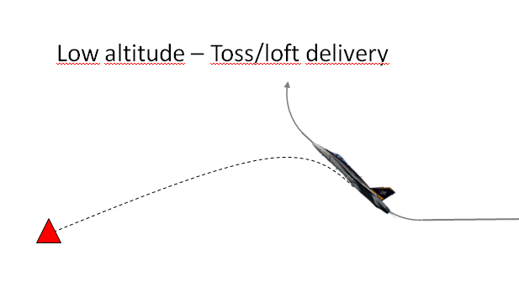

**Pop-up:** To execute a pop-up delivery the CAS flight proceeds to the target from the IP at low/very low altitude. As the CAS flight nears the target, they pop-up to the desired altitude and execute a level or dive delivery.

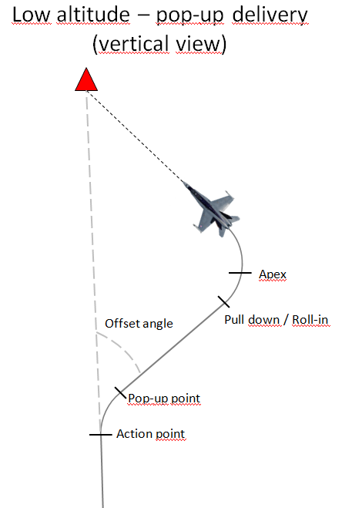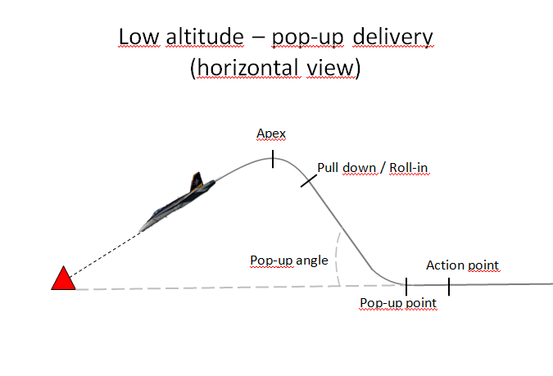

## **Gun deliveries**

**Low Angle Strafe (LAS)**

LAS have a planned dive angle at delivery of 15 degrees or less.

LAS deliveries are most effective against soft/lightly-armoured targets and will normally result in a higher dispersion of bullet impacts than high angle deliveries. The lower dive angle used on LAS deliveries allow for both lower aircraft speeds and operation at lower altitudes without the need for a pop-up profile, this allow the aircraft to carry out multiple passes on a single target in rapid succession and often allow the pilot to maintain visual contact with the target area throughout the attack. LAS deliveries are also ideal for attacking soft target such as supply convoys and troops.

The main disadvantages of LAS deliveries are increased exposure to enemy fire due to the low altitude and short range to the target, as well as relatively high bullet dispersion patterns resulting in reduced effectiveness against armoured targets.

Although the planned angle-off from the target can vary, normally the approach to the target is planned to be 15º–30º from the desired attack heading at a minimum of 450 KCAS. At the planned pop point, select military power and begin a 3–4 G pull-up to the desired climb angle. This is normally planned to be equal to the planned delivery dive angle plus 5º. At the preplanned pull-down altitude, roll the aircraft and begin a pull-down to achieve the desired dive angle. Monitoring the HUD pitch lines in relation to the target will simplify achieving the planned dive angle. Make an unloaded roll out with the CCIP pipper approximately 100' short of the target. After roll out, track and fire just as in a curvilinear/box strafing pass.

**High Angle Strafe (HAS)**

HAS have a planned dive angle of greater than 15 degrees.

HAS deliveries are most effective against heavily armoured targets such as main battle tanks and will normally result in a low dispersion of bullet impacts. HAS deliveries are also ideal for point targets where a tight bullet impact pattern is desired and/or where targets are located in mountainous terrain.

The main disadvantages of HAS deliveries are a limited tracking time due to the high aircraft speed in the dive and the need for an early escape manoeuvre to recover from the dive. It can also be difficult to maintain visual contact with the target due to the requirement for a high starting altitude. The need for a high starting altitude also places the aircraft at risk of early detection and/or high risk of engagement by SAM/AAA systems during the attack.

## **Low Level Deliveries**

**Visual Level Delivery (VLD)**

The VLD is a level delivery with a release angle of less than five degrees of climb or dive; it is often performed at very low level (below 1000 ft. AGL) utilising high drag munitions such as the MK-82AIR/MK-82 Snakeeye. The minimum recovery altitude is the safe escape/fuse arm range for the ordnance being delivered, or 200 feet AGL, whichever is higher.

Unlike pop-up deliveries (see below) the VLD is flown at a near constant altitude from ingress to the end of the SEM (and normally egress). The VLD will normally be used in situations where a NOE ingress and egress is required and only one attack on the target (per aircraft) is planned. When multiple aircraft will be attacking the same target, time and heading separation is vital it order to prevent following aircraft passing through any fragmentation and deny the enemy the ability to predict the arrival of attackers.

Visual Level Delivery (VLD) (0º–5º) This type of delivery is flown using CCIP when the weather or threat precludes steeper dive angles. Ingress the target area at low altitude, terrain masking and constantly jinking until just prior to weapon release. Since your approach to the target is a random flight path, good planning is required to arrive at an action point where target acquisition is initiated and weapons delivery commenced. If a level delivery is planned, simply arrive at the target on your proper altitude with the CCIP pipper properly positioned. If a 5º diving delivery is planned, initiate a 10º pull-up followed by a pull-down/bunt approximately 500' below planned apex. Pay particularly close attention to precise release parameters, fragmentation clearance and ground avoidance. The recovery portion of this delivery must be emphasized to ensure safe escape criteria from your munition.

**Dive Bomb (DB)**

The Dive Bomb delivery is probably the most familiar to the majority of pilots; it is performed with a dive angle of between 30 and 60 degrees and from a higher initial altitude than either LAHD or LALD. The minimum recovery altitude is the safe escape, or as required to recover above 1,000 ft. AGL, whichever is higher.

The DB delivery is a very accurate method of delivering weapons using CCIP. It should be noted however that due to the higher ingress altitude terrain masking is normally impossible and extreme care should be taken in high threat environments, as the delivery will bring the attacking aircraft well inside the MANPADS and AAA WEZ. Mutual support is vital to ensuring the safety of the attacking aircraft, and wingmen should be positioned in a way that allows a clear view of the target and the attacking aircraft’s ingress, attack and egress.

## **Pop-up attacks**

**Low Angle High Drag (LAHD)**

An LAHD attack, as the name would suggest is performed using high drag munitions such as the MK-82AIR/MK-82 Snakeeye, it is also used to deliver CBUs from low level. The delivery itself is carried out with a dive angle of less than 30 degrees and the minimum recovery altitude is safe escape/fuse arm for ordnance being delivered, one-half the computed altitude loss during dive recovery or 100 feet AGL, whichever is higher.

The LAHD delivery is usually performed with a low level ingress, similar to the VLD above, but rather than remaining at a constant altitude a “pop-up” is performed on the final ingress. This allows the attacking aircraft to remain at low level and utilize terrain masking (where possible) to remain out of range of any defenses at the target until the last possible moment. The aggressive nature of a pop-up followed by a dive attack further reduces the attacking aircraft’s exposure to ground fire, especially when combined with a low level egress.

LAHD is normally conducted using 10º–15º of dive. This attack maneuver is very similar to that of low-angle strafe. It is designed for low-angle delivery of high drag weapons. The approach to the target is normally planned to be made from a run-in heading offset 15º–30º from the attack heading at a minimum of 450 KCAS. At the desired pop point, a 3–4 G pull-up is initiated to the planned climb angle (usually dive angle plus 5º). At the preplanned pull-down altitude, the aircraft should be rolled towards the target and the nose pulled down to roll out just as you would in any low angle bomb delivery. Normally, this type of delivery is planned to allow 3–5 seconds of tracking/designate time prior to arriving at planned release altitude. For CCIP deliveries, roll out with the target approximately one-third down between the FPM and CCIP pipper.

**Low Angle Low Drag (LALD)**

An LALD attack is similar to the LAHD outlined above; it is also performed with a dive angle of less than 30 degrees and can be performed following a “pop-up”, although it can also be initiated from a level ingress at a higher altitude. The main difference is the weapon type used, whereas the LAHD is carried out with high drag munitions, the LALD (as the name would suggest) is performed with low drag munitions. The minimum recovery altitude is the safe escape/fuse arm height for the ordnance being employed, or 800 ft. AGL, whichever is higher.

The LALD delivery can be performed with a low level ingress and a “pop-up” on the final ingress or from a higher altitude without a pop-up. The main noticeable difference between an LALD and LAHD delivery is the altitude, at which the weapons are released, or the attack aborted, and the SEM must be carried out due to the reduced flight time and shallower flight path of the low drag munitions employed. This means that when performed with a pop-up from low level the climb is longer in duration and/or steeper.

The delivery is designed for low-angle delivery of low-drag weapons. Exercise care in computing

release altitudes to assure fuze arming and safe escape. Planned angle-off for this type of delivery can

vary from 15º–90º, although optimum angle is approximately 2 x climb angle. Accomplish pull-up to the

planned climb angle (15º + 5º and 20º + 10º) and pull-down at the preplanned pull-down altitude. Take

care to properly monitor the altimeter to determine the proper pull-down point since the apex altitude for a

LALD delivery is considerably higher than for a LAHD delivery and visual cues can be deceiving. For

CCIP deliveries roll out with the target approximately halfway between the FPM and CCIP pipper. Pay special attention to the altimeter to assure you deliver at or above the planned altitude.

**High Altitude Dive Bombing (HADB) (30º–45º)**  
This delivery is designed for high angle delivery of low-drag weapons in a high threat environment. During mission planning, aircraft configuration must be taken into account to ensure this type of approach is feasible, i.e., two wing tanks with six MK 82s may not be an option for high 45º delivery. The approach to the target is normally at 500 KCAS (minimum) to an action point 4–5 NM short of the target. At this point, a check turn between 20º–30º is required to obtain the necessary offset. At the desired pop point, a 4 G pull-up is initiated to the planning climb angle (usually dive angle plus 15º) in full AB. Once the pop-up is established, time should be devoted to target acquisition which can be difficult since you will be looking down over the canopy rail. Monitor the altimeter as the pull down altitude approaches due to the rapid climb rate to ensure correct parameters. At the apex, the aircraft will be at or nearly inverted, so care must be taken to roll out with the proper AOD. Attacks should be planned to provide 5 seconds of tracking/designate time prior to arriving at the release altitude. For CCIP deliveries, roll out with the target approximately two thirds of the way down between the FPM and CCIP pipper. After releasing weapons, the threat will dictate the type of recovery, but for peacetime training recover with a 4–5 G pull until the nose is above the horizon then execute the egress plan.

## **Medium/high altitude tactics.**

Are flown above 8,000ft above ground level(AGL). High altitude bombing can be described as bombing with the height of release over 15,000 ft AGL.

**Types of delivery**

**Level:** Used for guided and unguided free-fall weapons. Release point may have bomb ranges outside of visual range.

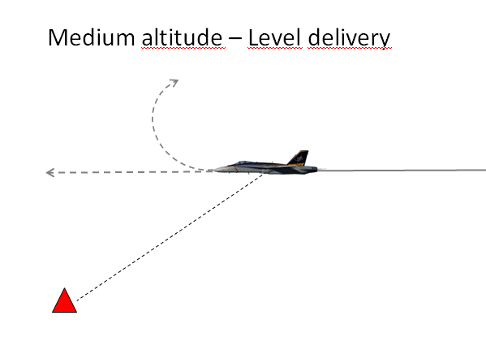

**Dive:** Used for guided, unguided and forward firing ordnance, these dive deliveries typically use dive angles of 15 to 60 degrees.

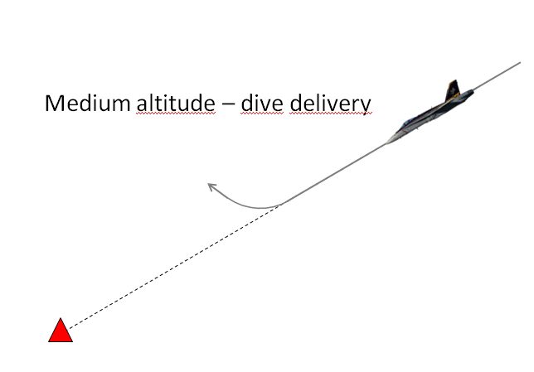

## **Medium and High Level Deliveries**

**High Altitude Dive Bomb (HADB)**

The HADB is almost identical to the Dive Bomb, the only real difference between the two delivery methods is the altitudes at which they are performed. Like the DB the HADB is performed with a planned dive angle of between 30 degrees and 60 degrees, but with a minimum recovery altitude of at least 4,500 ft. AGL.

The HADB, like the DB, is a very accurate method of delivering dumb munitions on target but due to the higher altitude at which it is performed it reduces the risk to the delivery aircraft from SHORAD systems such as AAA or MANPADS. It should be noted that 4,500 ft. AGL is the minimum recovery altitude for the HADB delivery and pilots/flight leads can set a higher minimum recovery altitude if desired/appropriate.

When performing a HADB delivery it is vital that the pilot pays attention to the altitude and airspeed in the dive, as well as the amount of time spent tracking the target. It is all too easy to become fixated on the target, ignore the HUD and voice cues and then find yourself below the minimum recovery altitude in the range of the SHORAD systems you were hoping to avoid, or even colliding with the terrain. The tracking phase of HADB deliveries should be less than 6 seconds; excessive time spent in the dive trying to force the pipper on the target from a poorly executed dive/turn is without doubt the biggest mistake pilots make.

**High Altitude Release Bomb (HARB)**

HARB is a diving delivery with a planned dive angle of 30 degrees or greater, just like DB and HADB, where it differs is the minimum recovery altitude (and therefore the release altitude). The minimum recovery altitude for a HARB delivery is 10,000 ft. AGL, twice the height of the HADB.

Due to the high release altitude, and therefore large slant range, accuracy is limited (despite still being a CCIP delivery) which means the HARB is of limited value when attacking small, mobile targets such as vehicles and troops. It is worth noting however, that HARB may be useful in cases where it is important to get weapons on target but the threat situation makes a low level attack inappropriate. When planning such a delivery the reduced accuracy should be considered and thought given to using multiple aircraft against a single DMPI to ensure sufficient weapons impact the target in order to achieve the desired effect.

## **Toss Deliveries**

Weapon delivery in which an aircraft system is used for target designation followed by a climbing Continuously Computed Release Point (CCRP) weapon release. It should be noted that toss deliveries are generally less accurate. Another name for toss deliveries is loft.

**Low Altitude Toss (LAT)**

LAT deliveries involve a release altitude below 10,000 ft. AGL all the way down to 0 ft. AGL. The minimum recovery is the safe escape altitude/distance for the ordnance being delivered.

The LAT delivery is the most accurate CCRP delivery as the low release altitude limits the effect of wind and aiming error on the weapons during their flight. While easier to perform than a diving CCIP delivery, the LAT delivery is also less accurate and may require releasing more weapons and/or more attacks to deliver the same damage to the target as a single diving delivery. Due to the release aircraft’s attitude and airspeed at the point of weapon release, the weapon time of flight will be greater than a diving delivery with the same release altitude.

As it already says, this is a low altitude profile. The idea for this delivery is to fly in low and below the radar and also give you some distance from the target at the same time. You will toss the bombs from a distance and turn away before you over fly the target. This will give you the advantaged of surprise and you stay as far as possible from the target. The disadvantage of this delivery is that the accuracy is lower then the other modes. So you have to select this profile only when everything fits to the occasion. Using guided weapons is a good option, and also cluster bombs will fit very nice. Unguided bombs are not so good for this profile because you will probably miss the target unless the target is very large like a hanger.

**Medium Altitude Toss (MAT)**

A MAT delivery is identical to the LAT described above but with a release altitude of 10,000 ft. AGL or above. The minimum recovery is the safe escape altitude/distance for the ordnance being delivered.

The MAT delivery has the same list of pro’s and con’s as the LAT, the notable difference being the higher altitude magnifies the effects of wind and aiming error on weapon accuracy. While the higher altitude may negate the threat posed by AAA and/or MANPADS it should be considered that it makes the delivery aircraft and even better target for hostile aircraft and MERAD/LORAD systems.

# **Chapter 3: Useful information**

## **Three Point Attack Brief**

The Three-Point -Attack  Brief is the standard  attack briefing designed to  give the information needed to  perform an attack quickly. The brief assumes that as a minimum the engaged fighter has acquired the  target, and is the minimum information considered necessary to execute an attack:

**Initial Point (IP)**

The point from where the attack starts. Can be a waypoint, geographical feature or a holding area (wheel, racetrack). If no information is given, the attack is conducted from formation.

**Method of Attack**

Roles, Attack formation, and type of attack, weapon.

**Egress**  
Safe escape maneuver, egress direction or point. Can be a heading or a point like IP,and can contain  instructions for additional  attacks using the same brief.

## **Fence Check**

“FENCE IN” is  a cockpit switch  check to confirm that  all onboard systems and  profiles are set up for combat.  Think “jumping over the fence” and  into enemy territory.

“FENCE  OUT” is  conducted to  de-arm and check  the aircraft for damage  and hung stores after the  conclusion of combat operations.

FENCE  checks are  typically conducted  before the flight arrives  at or leaves its check-in point.

Set  the systems  according to pre-briefed  values if available.

|  |  |  |
| --- | --- | --- |
| **F** | Fire control  systems: | A-A/ A-G Mode, Stores page and weapon profiles, EO timer , IR Cooler and MASTER  ARM |
| **E** | Electronic  Warfare: | Countermeasures, ECM, RWR, |
| **N** | Navigation  Systems: | HSI set, fuel  quantity, fuel |
| **C** | Communications Radios: | On correct  preset/frequency , IFF, Datalink (SA page) |
| **E** | Emitters: | TACAN, Radar  and external  lights |

## **Attack methods**

Roles:

##### Shooter:

Primarily responsible for putting munitions on target.

##### Cover:

Responsible for providing mutual support to the other flight member. Specific requirements for this role will be briefed by the flight lead.

##### Marker:

Marker is assigned to a pilot who will employ the TGP during the attack. Pilots assigned this role can expect to mark the target with the laser and/or IR marker for target identification purposes and/or LGB guidance.

##### Decoy:

Flight member’s primary responsibility is to create confusion, deny or delay enemy defences to keep them from engaging the attacking aircraft.

#### Shooter-Cover

Here the  shooter will focus on target acquisition and release of weapons whilst the other  aircraft flying ing a cover role will support the shooter by:

-Scanning  visually for  threats (smoke  trails, traces, muzzle  flashes)

-Scanning  the RWR and Radar

-Immediately  call threats to  the other aircraft,  and a directive on how  to defeat the threat

#### Shooter-Shooter

These are  attacks where  both aircraft fire  weapons during the same  attack run. This attack type  is generally reserved for “stand-off”  weapons such as Mavericks, where the attacking  flight does not overfly hostile ground or fly within  the engagement envelope of the target. I.e., the flight  performs a trade-off between the security offered by having  a dedicated supporting fighter and added firepower in a single  run.

Shooter-shooter  attacks are typically  conducted from Line abreast, Wedge or  Fighting Wing.

Shooter shooter attacks can also be spaced out with a time separation (For example “shooter-shooter, 30 sec spacing”).

#### Shooter- Decoy

This is primarily used against enemy Air Defences where one aircraft uses itself as bait for the air defences, for examply by having a SAM lock the decoy aircraft up, and fire against the decoy aircrafts allowing the shooter to operate inside the Weapon Engagement Zone (WEZ) without being shot at.

#### Shooter-Marker

WILL BE ADDED LATER

### **Mutual support Attack Geometry**

Cover pilots must consider the attack geometry when attacking from a medium altitude in order to provide continuous mutual support. Monitor the target area and “shooter” while maintaining turning room so you can roll-in if called upon to employ munitions. The most critical part of mutual support during an attack and recovery is visual. It is difficult for the attacking aircraft to clear its 6 o’clock while maneuvering off the target because of the higher delivery altitudes. Two methods to help reduce loss are:

#### Arcing the Target

As the “shooter” rolls in the cover aircraft continues to arc the target. You must arc far enough away so the entire target area can be seen but close enough to maintain a visual on the “shooter” aircraft during roll-in and recover. A good technique is to keep the target area on the canopy rail, this permits a dive angle of approximately 45° if required to roll-in. When in trail or wedge prior to roll-in it will be difficult to use this technique since the “shooter” will be traveling away from your aircraft’s position. When possible, the cover aircraft will art toward the direction of the pull-off location of the “shooter.

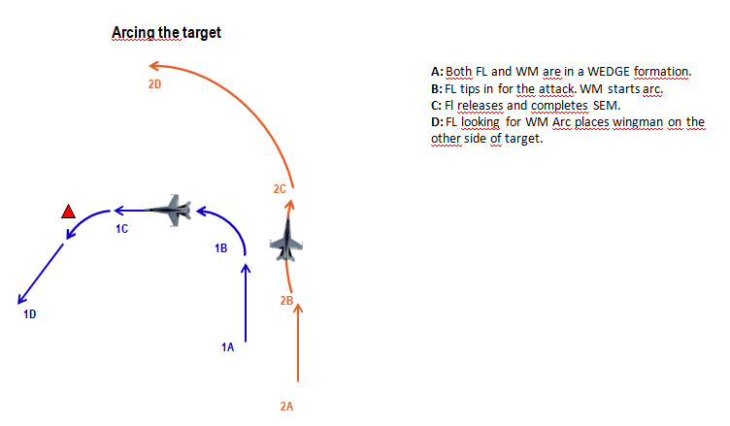

#### Parallel Attack Axis

Similar to Arcing, the different is the “shooter” provides a verbal cue to clear the cover aircraft to maneuver parallel the attack axis. The verbal cue will be briefed prior to the attack either on the ground or in the air. The cover aircraft establishes a position to employ ordnance and monitor the target area and “shooter” during roll-in and pull-off. When the “shooter” pulls-off the cover aircraft will be in a predictable point aiding the “shooter” regaining visual. This will minimize “Blind” calls from the “cover” or “shooter.”

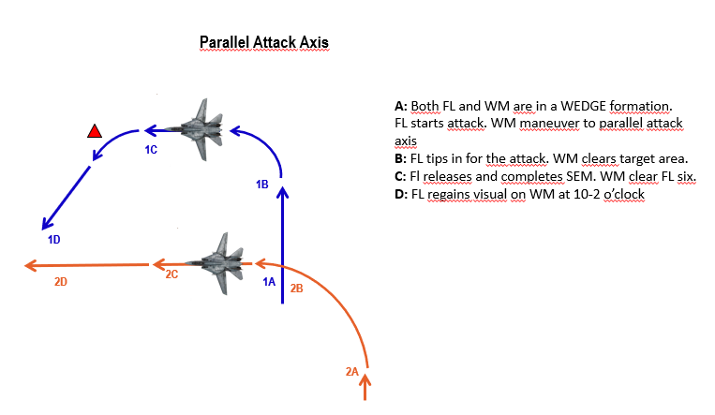

#### **High/medium altitude tactics**

#### Shooter-Cover

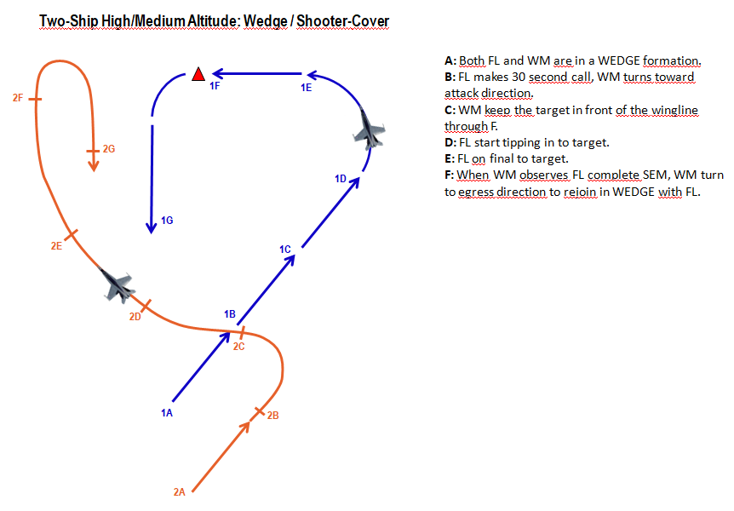

Shooter-Shooter

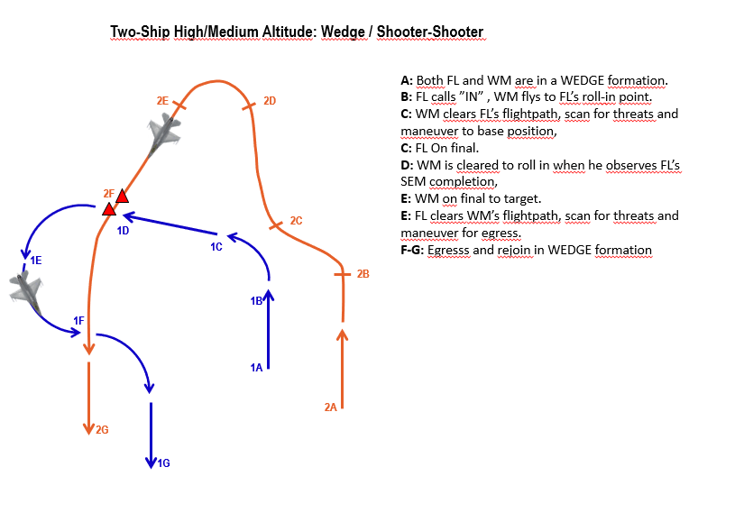

##### Two-ship high/medium altitude: Line abreast , standoff attack/ shooter-shooter

##### 

#### **Low altitude tactics**

#### Shooter-shooter

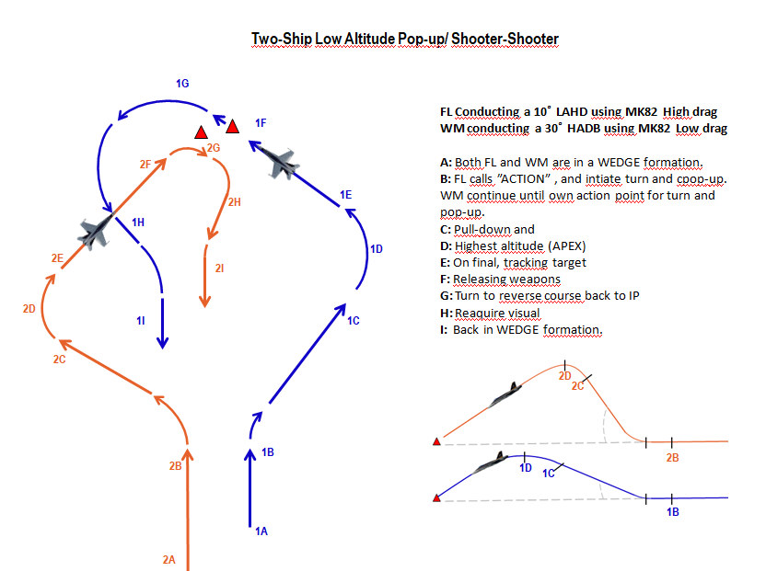

Figure 1: In this attack FL have a actionpoint 5,1 nm away from the target, flying at a speed of 500kts at 400ft AGL. At Action, FL does a 20 degrees right turn, and conducts a 3-4 G pull to 15 degrees with full AB. APEX at 1700ft AGL (target altitude). WM have a actionpoint 5,1 nm away from target, flying at 500kts at 400ft AGL. At Action, WM does a 30 degree right turn and conducts a 4G pull to 45 degrees with full AB. APEX at 5800ft AGL (target altitude).

##### Two-ship low altitude: Line abreast, Maverick attack / Shooter-Shooter

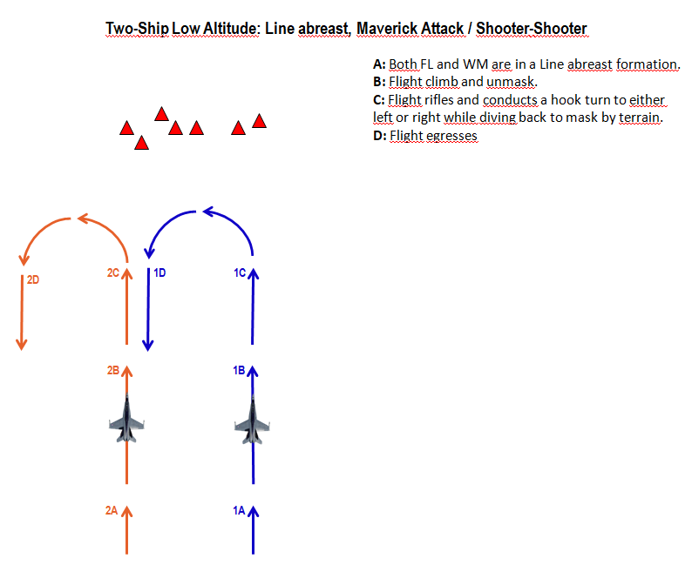

## **Buddy lasing**

WILL BE ADDED LATER

## **Ground lasing**

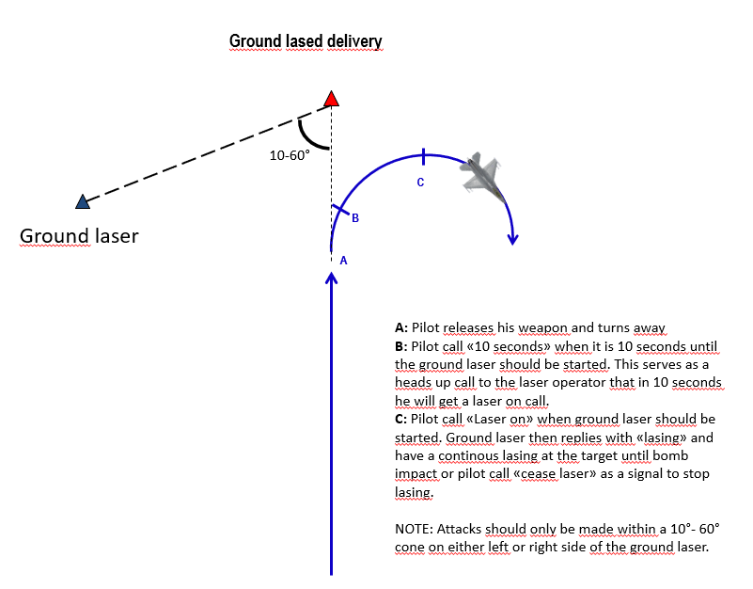

## **Holding patterns**

At times it may be necessary to hold at a specific point, or area in order to

When possible the flight should hold in a area with enough airspace to hold in an area of relatively low AAA/SAM activity that also provides a good position to observe the target area.

Racetrack: An oval holding pattern with straight legs and with standard 180 degree turns on each end. Racetrack is anchored into a fix which can be TACAN or waypoint or a geographical feature.

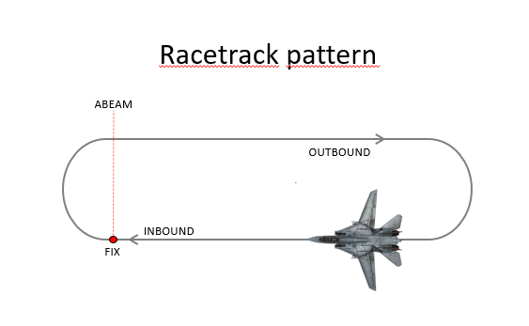

Figure Eight: The same as racetrack pattern except the turns at each end of the pattern are made toward the target area or a fix and are 230 degrees of turn instead of 180 degrees.

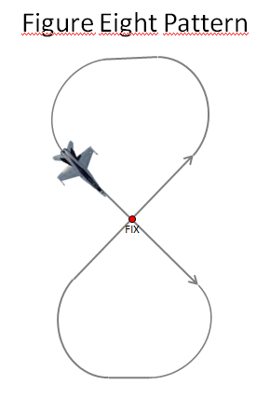

Wheel orbit: Circle around the designated target or a fix. Appropriate for nonlinear battlefields with pockets of enemy activity

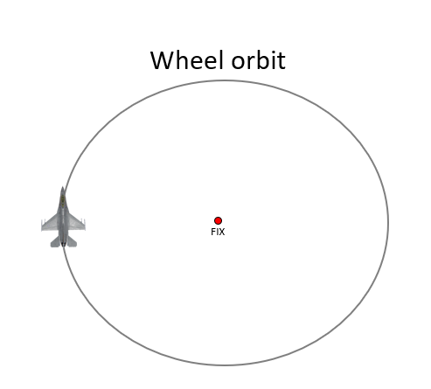

## **Range pattern**

WILL BE ADDED LATER

### **Safe Escape Maneuvers (SEM)**

**Level Straight Through (LST)**

This is the simplest of the SEMs and is exactly what its name suggests; safe escape is provided by a level, constant speed, no-turn profile. Maintain this SEM until 3 seconds after the TOF of the last bomb in the stick. This is only used with a level release, like the VLD you might use with MK-82AIRs.

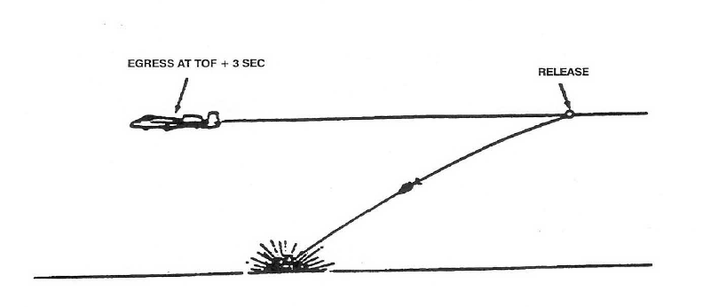

**Turning (TRN)**

It's valid for attacks using up to 20° of dive. After release, simultaneously apply MIL and establish a 4g loaded roll (60-85° of bank) in the desired direction. As the TVV nears 5° of dive increase your bank angle to maintain 4g and 5° of dive for at least 60° of heading change.

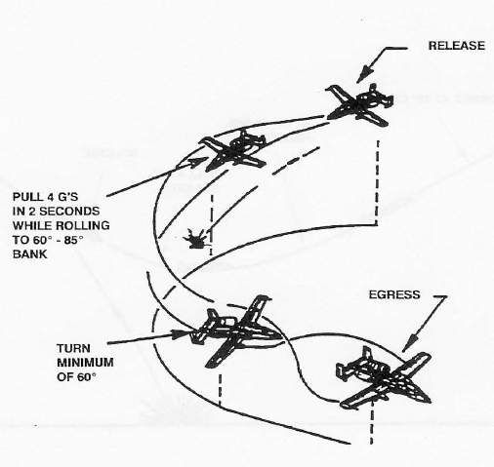

**Turning Level Turn (TLT)**

This is far more common than TRN, and is also used for deliveries with up to 20°. After release, simultaneously apply MIL power and establish a wings-level 4g pull within 2 seconds. As the TVV nears the horizon, perform a 2-4g loaded

roll in the desired direction and establish a 4g level turn for at least 60° of heading change.

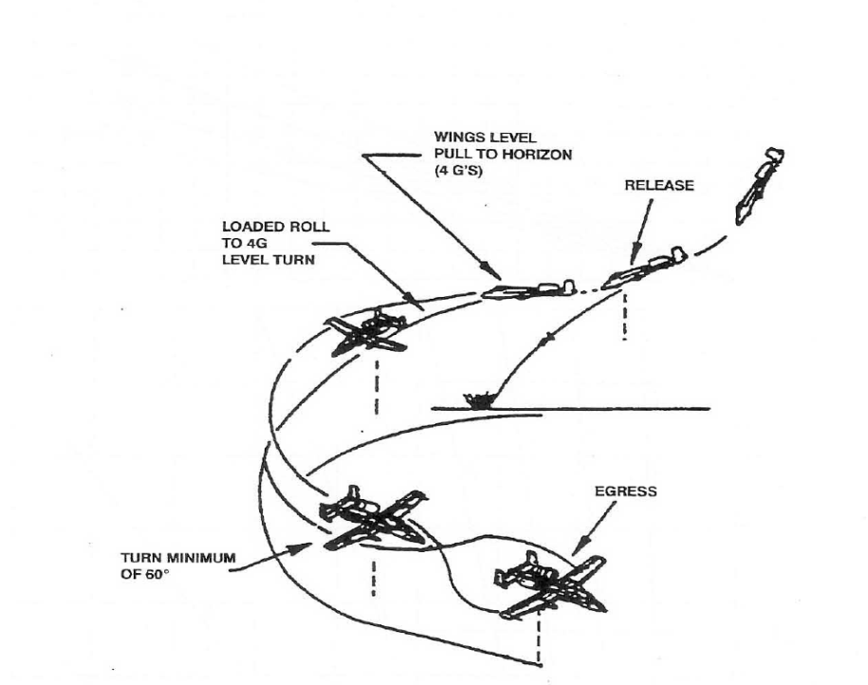

**Climb (CLM)**

The CLM SEM can be used for attack profiles with as much as 60° of dive. After weapon release, establish a 4g pull within 2 seconds. As the nose approaches the horizon, apply MIL power and maintain the 4g pull until the TVV is 20°above the horizon, and then relax the pull until the TVV indicates at least a 30° climb.

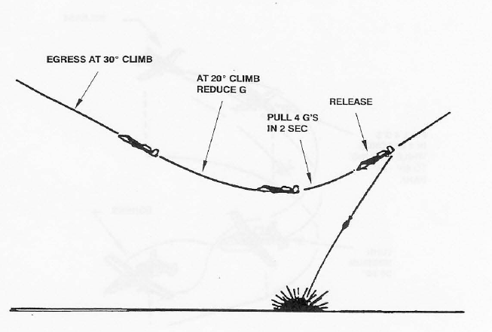

# **Chapter 4: Z-Diagrams**

##### Z-Diagram explanation Pop-up attacks

This is the maximum altitude during the attack

What kind of profile is shown

This is distance is the action point, where the turn to either side is initated

This is how many degrees to either side is the offset before doing the pull-up

How many degrees is the pop-up.

This is the Planned Release Altitude. Also gives the Minimum release Altitude

This is the dive angle during final

At what altitude should the pilot start his roll-in / pull-down toward target

This is the minimum altitude during the profile

##### Z-Diagram attack profiles High altitude and Medium altitude dive bombs

### 

What kind of profile is shown

### 

What altitude to be at when flying the base-leg

This is the dive angle during final

Speed at weapon release

What speed to be at while flying at the base-leg

Distance at when to tip-in while flying base-leg (Slant range)

This is the minimum altitude during the profile

This is the Planned Release Altitude. Also gives the Minimum release Altitude

## **Z-Diagrams 494th**

##### Z-Diagram attack profiles Pop-up attacks

#### Low Angle Strafe

#### High Angle Strafe

#### 10˚ Low Altitude High Drag (LAHD)

#### 30˚ Low AltitudeLow Drag (LALD)

#### 40˚ High Altitude Dive Bomb (HADB)

## **Z-Diagrams 388th**

##### Z-Diagram attack profiles Pop-up attacks

##### Z-Diagram attack profiles High altitude and Medium altitude dive bombs

## **Z-Diagrams 108th**

##### Z-Diagram attack profiles Pop-up attacks

##### Z-Diagram attack profiles High altitude and Medium altitude dive bombs